**Applied Software Project Report**

By

Amritendu De

**A Master’s Project Report submitted to Scaler Neovarsity - Woolf in partial fulfillment of the requirements for the degree of Master of Science in Computer Science**

September, 2024



**Scaler Mentee Email ID :** amritendu_de@yahoo.com

**Thesis Supervisor :** Naman Bhalla

**Date of Submission : 21st September, 2024**

**Certification**

I confirm that I have overseen / reviewed this applied project and, in my judgment, it adheres to the appropriate standards of academic presentation. I believe it satisfactorily meets the criteria, in terms of both quality and breadth, to serve as an applied project report for the attainment of Master of Science in Computer Science degree. This applied project report has been submitted to Woolf and is deemed sufficient to fulfill the prerequisites for the Master of Science in Computer Science degree.

Naman Bhalla

…………………

Project Guide / Supervisor

**DECLARATION**

I confirm that this project report, submitted to fulfill the requirements for the Master of Science in Computer Science degree, completed by me from 5th March, 2024 to 10th June, 2024, is the result of my own individual endeavor. The Project has been made on my own under the guidance of my supervisor with proper acknowledgement and without plagiarism. Any contributions from external sources or individuals, including the use of AI tools, are appropriately acknowledged through citation. By making this declaration, I acknowledge that any violation of this statement constitutes academic misconduct. I understand that such misconduct may lead to expulsion from the program and/or disqualification from receiving the degree.

**Amritendu De**



**Date: 21st September, 2024**



**ACKNOWLEDGMENT**

**I would like to take this moment to express my deepest gratitude to my family, whose unwavering support and encouragement have been my foundation throughout this journey. To my Scaler instructors, thank you for your invaluable guidance, expertise, and patience, which have played a crucial role in shaping my knowledge and skills. I am also incredibly grateful to everyone who has inspired or motivated me along the way, whether through words of wisdom, moments of insight, or acts of kindness. Your collective belief in my potential has been instrumental in my ability to complete this program and earn my Master’s degree.**

**Table of Contents**

List of Tables 6

List of Figures 7

E-Commerce Application 8

Features 8

ER-Diagram 11

Swagger 12

API Controllers 12

Conclusion 14

## List of Tables

|  |  |  |
| --- | --- | --- |
| **Table No.** | **Title** | **Page No.** |
| **1** |  |  |
| **2** |  |  |

## List of Figures

**(List of Images, Graphs, Charts sequentially as they appear in the text)**

|  |  |  |
| --- | --- | --- |
| **Figure No.** | **Title** | **Page No.** |
| **1** | **ER Diagram** | **11** |
| **2** | **Swagger** | **12** |

# E-Commerce Application

* The E-Commerce Application is built using Java and Spring Boot, with security, scalability, and ease of maintenance. The backend uses Spring Data JPA to interact with a MySQL database, making it easy to manage and store important entities such as users, products, categories, orders, and more. User authentication is handled by Auth0, providing secure and reliable means of REST APIs.
* The APIs are well-documented and easily accessible through Swagger UI, making it simple for developers to test and understand the various endpoints. Overall, this project provides secure Rest APIs to create a scalable platform for businesses to sell their products to customers.

## Features

**Admin**

* Login
* Users
* Address
* Categories
* Products
* Price & discount
* Orders

**User**

* Registration & Login
* Fetch categories and products based on category
* Adding & deleting products to cart
* Managing address and products quantity
* Ordering products and fetching order status

**Security**

* The API is secured using JSON Web Tokens (JWT) handled by Auth0. To access the API, you will need to obtain a JWT by authenticating with the /login endpoint. The JWT should then be passed in the Authorize option available in the Swagger-ui.

Example: Authorization: <your_jwt>

**Technologies**

* Java 21
* Spring Boot 3.0
* Maven
* MySQL
* Spring Data JPA
* Spring Security
* JSON Web Tokens (JWT)
* Auth0
* Swagger UI

**Running the app**

* Clone the repository: git clone <https://github.com/amritendude/scaler-backend-ms-project.git>
* Import the project into STS:
* Click File > Import...
* Select Maven > Existing Maven Projects and click Next
* Browse to the project directory and click Finish
* Update the values in application.properties with your MySQL database connection details.
* Run the app: Right-click the project in the Package Explorer and click Run As > Spring Boot App.

**API documentation**

* API documentation is available via Swagger UI at <http://localhost:8080/swagger-ui/index.html>

## ER-Diagram

[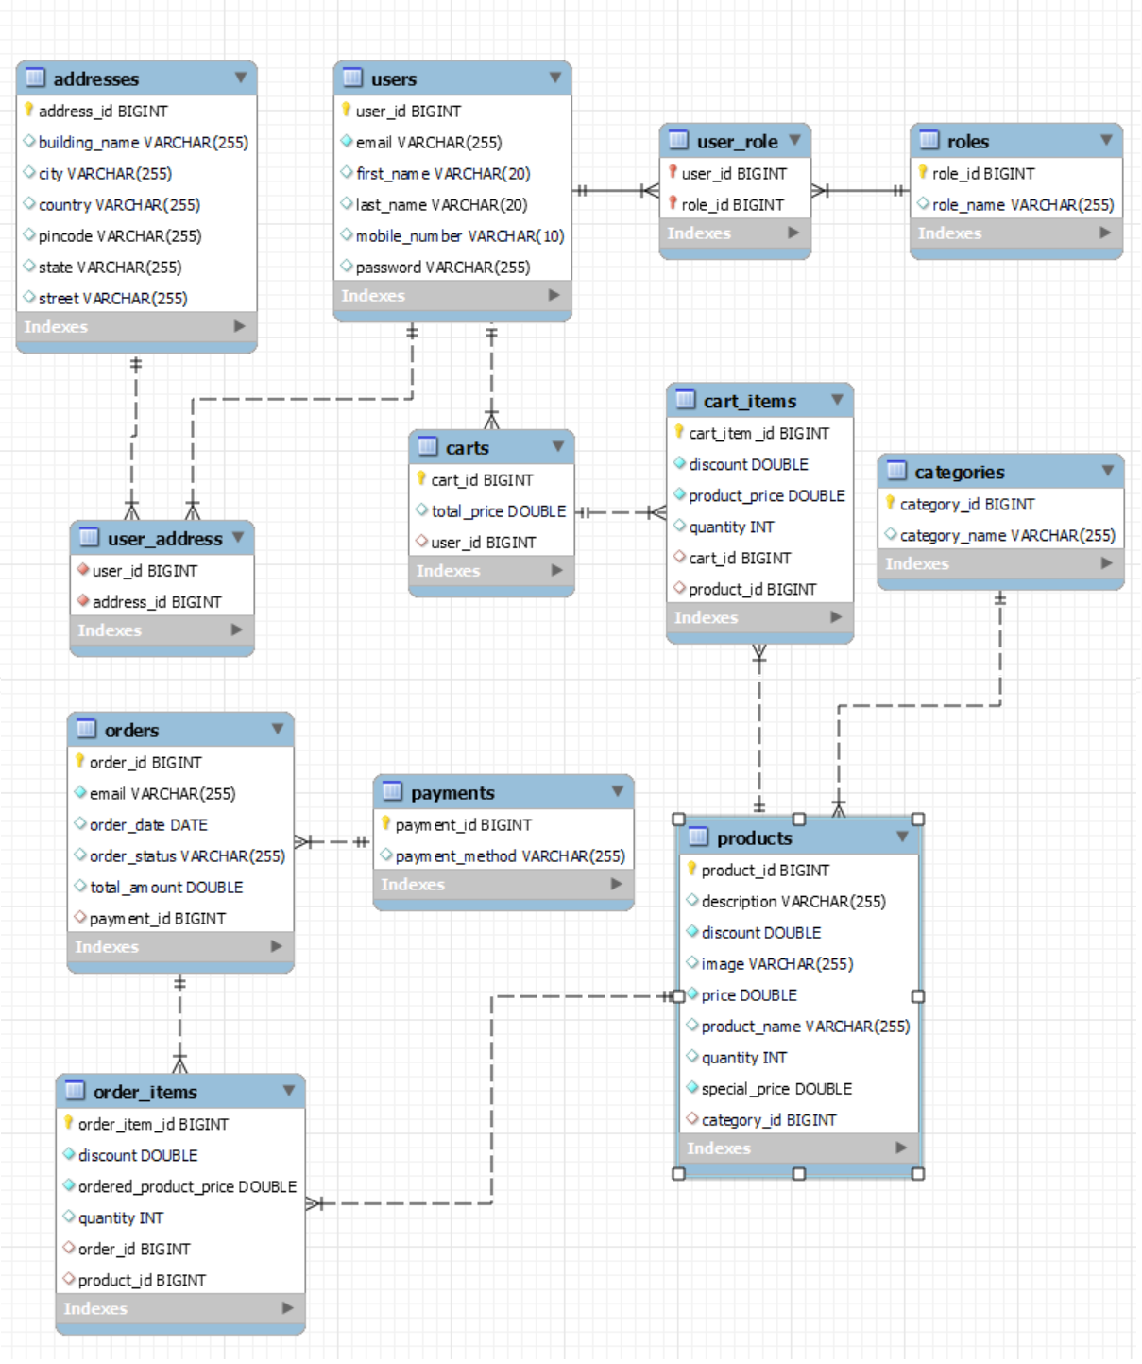](https://user-images.githubusercontent.com/101395494/216134703-e7cefef6-187f-44df-9fd4-52aedc66d24b.png)

Figure 1 : ER Diagram

## Swagger

[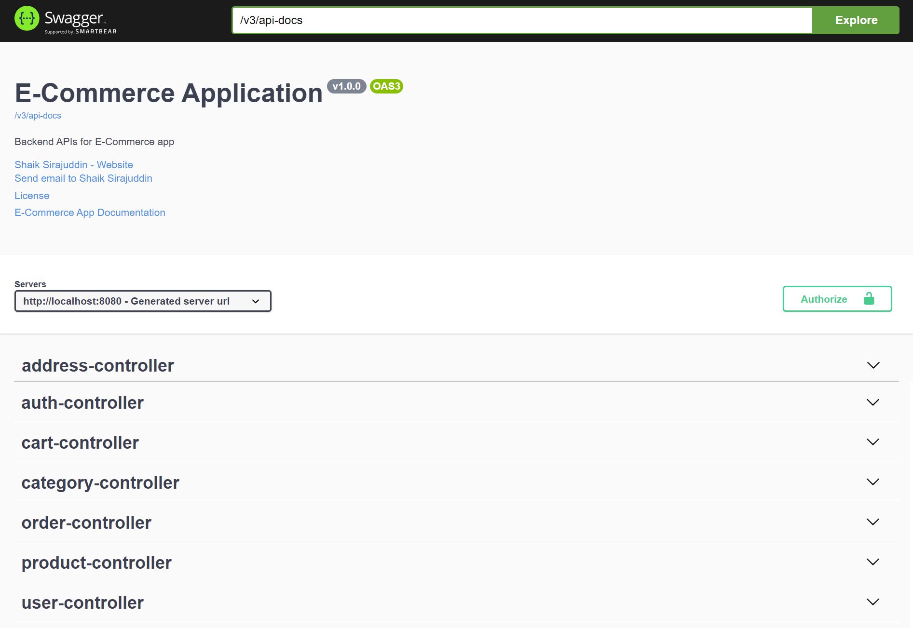](https://user-images.githubusercontent.com/101395494/216388614-f8eed33e-cbbb-4cfa-997e-b76674bbb465.png)

Figure 2 : Swagger Screen Shot

## API Controllers

[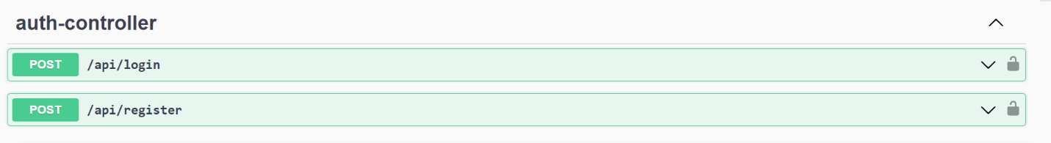](https://user-images.githubusercontent.com/101395494/216388749-4f15d968-ae52-48a9-9c08-0b72d608084a.png)

[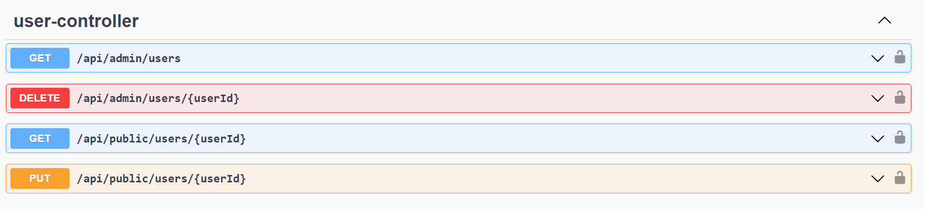](https://user-images.githubusercontent.com/101395494/216755281-ebacb2a4-3f02-4d41-a695-d508ee537db1.png)

[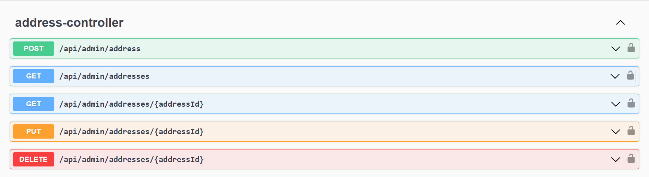](https://user-images.githubusercontent.com/101395494/216388840-0a31a552-63e3-4b10-9fab-c6c705cd7af4.png)

[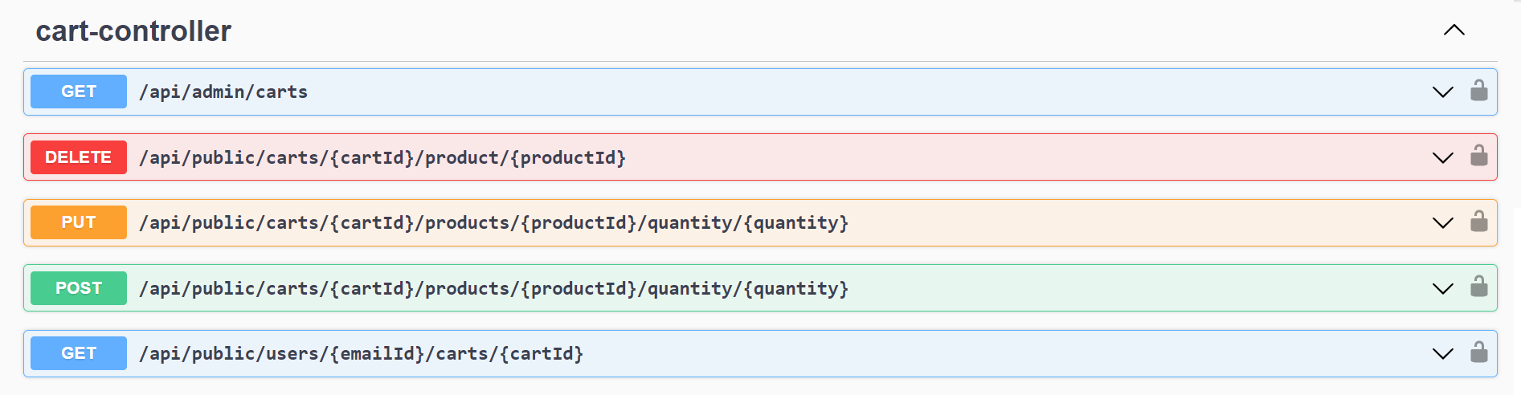](https://user-images.githubusercontent.com/101395494/216388895-736fa8c1-7784-4d4d-8768-c619e6fd0e6f.png)

[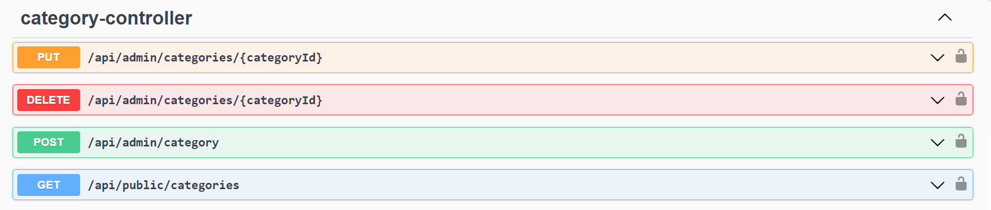](https://user-images.githubusercontent.com/101395494/216388926-88c45391-d35b-4359-b239-86acb63ccb6b.png)

[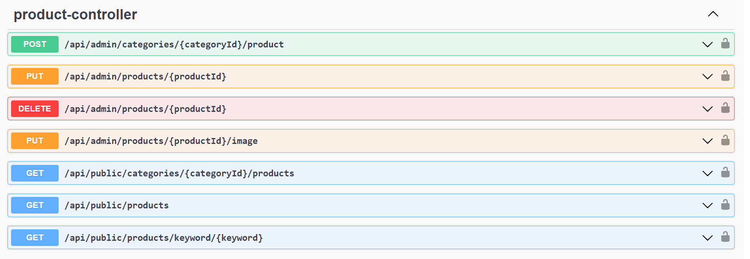](https://user-images.githubusercontent.com/101395494/216755314-56904892-4a1d-4bc3-b40d-b9d76525ec83.png)

[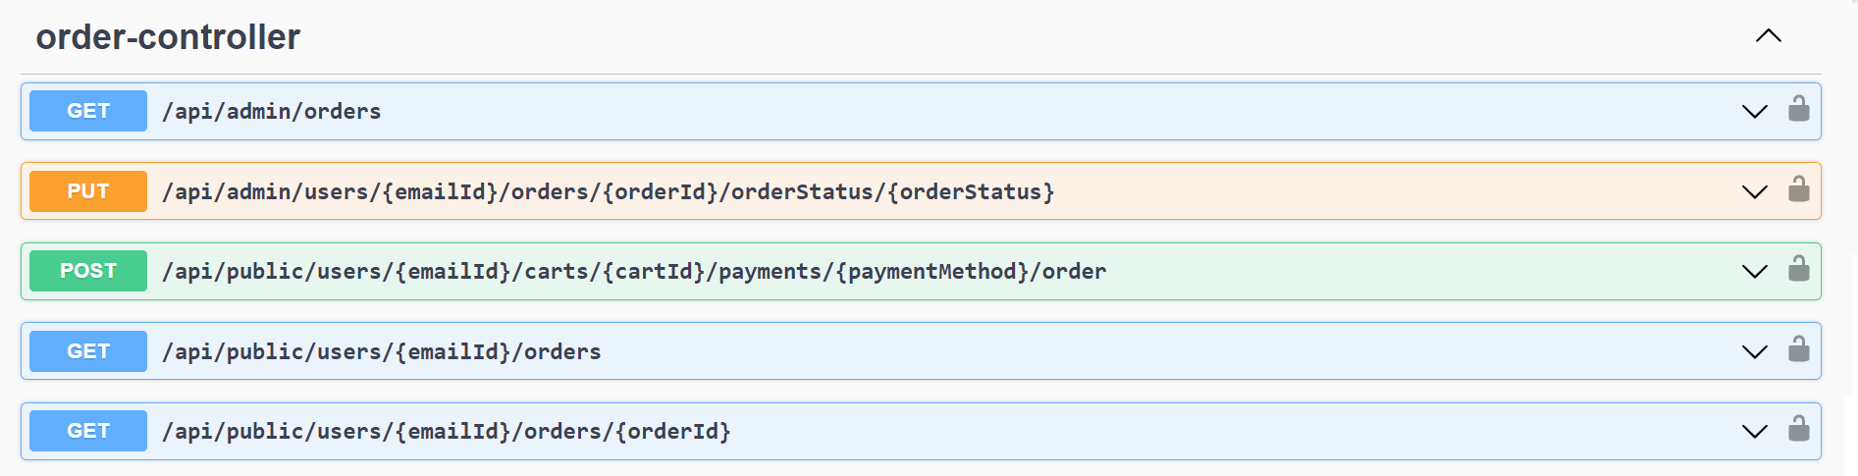](https://user-images.githubusercontent.com/101395494/216388971-7d654a8e-6abc-4548-80c6-8d1173f56bc4.png)

## Conclusion

In conclusion, this project aimed to develop a comprehensive eCommerce application that integrates essential features such as user registration, product catalogue management, shopping cart functionality, secure payment processing, and order tracking. Throughout the project, best practices in software development, including modular design, secure authentication, and responsive user interface, were applied to create a seamless and efficient shopping experience for users.

By leveraging modern technologies and frameworks, the application not only meets the functional requirements but also ensures scalability, performance, and security. The completion of this eCommerce application represents a significant milestone in the practical application of theoretical knowledge, demonstrating the ability to design, develop, and deploy a fully functional web-based system. This project lays the foundation for future enhancements and further growth in the ever-evolving digital marketplace.